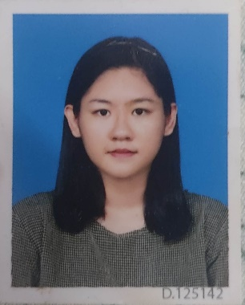

**CURRICULUM VITAE**

Name Ma Thet Htar Sann

Gmail thethtar1707@gmail.com

Phone Number 09955729289

Address No (36), Aung Thiri Street, 28 quarter,

North Dagon, Yangon

**Personal Data**

Gender Female

Age 22

Date of Birth 17/7/2000

NIC NO 12/DAGAMA(NAING)032100

Father U Tin Htut Win

Mother Daw Yin Min Htike

Religion Buddhist

Nationality Burma

**Education**

Degree 4th year at University of Computer Studies, Yangon

Certificate English 4 skills in Pre-intermediate at Strategy First,

Computer basic at KMD,

(SQL fundamentals course,

Python for Beginners) at SOLOLEARN,

Python for Everybody

at an online non-credit course authorized by University of Machigan and offered through Coursera

**Skills**

IT HTML, CSS, JavaScript, Java, Python, SQL database,

Microsoft Word, Power Point, Excel

Language Japanese level N3

English Intermediate 4 skill